Monday 26th -

Canva Link: https://www.canva.com/design/DAEbe5M1FMs/share/preview?token=AG_lu-XZIX9QM4GGxGOiAw&role=EDITOR&utm_content=DAEbe5M1FMs&utm_campaign=designshare&utm_medium=link&utm_source=sharebutton

Quote: "I'm articulate, I swear! Why do I sound so dumb when I write?"

Caption:

Because you allowed the voice of your English teacher - come out.

Or a sales bot or Shakespeare.

It’s not your fault it’s because most of us were taught that ‘formal’ means ‘professional’.

And that’s not the case in entrepreneurship today.

#lamidejohnson

-----------------------------------------------------------------------------------------------------------------

Tuesday 27th:

Canva Link: https://www.canva.com/design/DAEa4BlGa48/share/preview?token=5jCYtGYr7urhLyOhrfNdHg&role=EDITOR&utm_content=DAEa4BlGa48&utm_campaign=designshare&utm_medium=link&utm_source=sharebutton

1 Slide: "I just don't think I'm a good storyteller."

Caption:

No one is born a storyteller. At least - not me.

Yes, I am called a Master Storyteller, but I wasn’t always a great storyteller.

Here’s what has helped me tell stories -

I have learned to see everything as a story. This is most definitely a useful place to start.

And you can learn it.

And even master it.

Just like learning to drive a car.

If you think it’s okay for people to go to a driving school to learn to drive.

Wouldn’t it be wise to enrol in a writing school too?

You missed the Storywriting Bootcamp for the month of April. I only take 25 students at N20,500 each. Make sure you don’t miss the next cohort.

#lamidejohnson

-----------------------------------------------------------------------------------------------------------------

Wed 28th -

Canva Link: https://www.canva.com/design/DAEa4GF7n0M/share/preview?token=uYLfTcznnkF9qfqyFnt8DQ&role=EDITOR&utm_content=DAEa4GF7n0M&utm_campaign=designshare&utm_medium=link&utm_source=sharebutton

Quote: "People stop me on the street to thank me for my instagram posts"

Caption:
Once, I was on the streets of Lagos - Lekki, right in front of a gift store, waiting for my ride to pick me up. Suddenly, I heard someone scream my name!

“Lamide Johnson!!!”

Then he added.

“Thank you for your Instagram Posts!!!”

I stood there, shocked. Looked around to see if anyone caught the most beautiful scene, then smiled like a boy who just had his first kiss.

Here’s the brutal truth -

If someone drops their ego and stops you on the street for this - there’s only one thing;

You’re a damn good writer.

#lamidejohnson

---------------------------------------------------------------------------------------------------------------

Thursday 29th -

Canva Link: (pending your approval before I create)

1: Your customers like these
2: They like when you make them feel seen.
3: They like it when you put them first before your business
4: They like when you ask these questions;
5: What can my company do to better serve your needs?
6: How satisfied are you with our products/services?
7: What value do we provide?
8: What are your biggest challenges?
9: Why did you choose us over the competition?
10: Do you have a feedback strategy?

Caption: When you buy something from a IG vendor, how many of them message you after a while for feedback on their product/service?

I bet your answer is none?

LOL.

Most businesses don’t care about these little things that can help customers remember your business exists or forget they ever did business with you.

Occasionally, checking in with past customers will eventually lead to repeat customers. And these customers can tell their other friends about how you made them feel so special by always seeking their feedback.

Do you have a feedback strategy?

#lamidejohnson

--------------------------------------------------------------------------------------------------

Friday 30th -

Canva Link: (pending your approval before I create)

1: Stop Trying So Hard To Create A Brand Personality
2: Develop a “brand personality” - we hear it all the time.
3: Do this instead;
4: Make your “personality” the “brand”?
5: Your brand personality isn’t a video of you pointing at words on your IG reels.
6: It isn't "Hey guys, xyz" in an attempt to make people feel like they're a part of a community.
7: Your brand personality comes from your own personality. ⁣⁣⠀
8: The more "you" - you put into writing for your business, the more you'll attract the right people.⁣⠀⁠
9: The more "you" you put into your writing, the faster people would love your business like a cappuccino coffee and the more you'll get paid to be you.
10: Is your personality your business?

Caption: As an entrepreneur - how DO you show your personality? ⁣⠀⁠

Do you share concrete details?

I mean things almost all your competitors don’t share.

Do you write for your audience in such a way they feel like they've gone for a ride with you before?

By being intimate with your audience in every part of your business (especially your writing). Captions, Stories, Posts, etc…..

Not only will this unique personality distinguish you in the sea of competition; the more you express who you are, the more people will know, like and trust you without ever having met you. And that bond is what gets them happily whipping out the ATM card.

#lamidejohnson

-------------------------------------------------------------------------------------------------------

Saturday 31st -

Canva Link: https://www.canva.com/design/DAEcw6ysLZ4/share/preview?token=NrtWe6WBNZtWxp0DPA3wMw&role=EDITOR&utm_content=DAEcw6ysLZ4&utm_campaign=designshare&utm_medium=link&utm_source=sharebutton

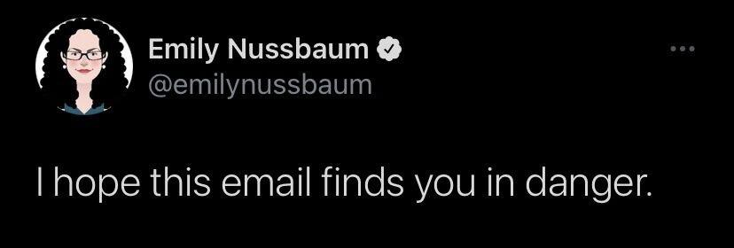

Caption: Not to scare you.

Is it just me that has a problem with the line “I hope this meets you well” ?

It makes my tummy rumble.

How do you know your message met me well?

What if I’m having a bad day because I just got off a heated argument with a friend. (even though Lamide can barely kill an ant).

But what if?

I sent this to my email list last week friday and got some hilarious and transformational responses. Some even said they immediately block the person. (LOL. please read it at least before you block).

In the email - I also shared my experience with those rude spammers with 2 followers seeking to help me grow my IG account. And they start their message with “hope this meets you well?”

Of course - it didn’t, spammer! (BLOCKED!)

Anyway, What’s your default response to “hope this meets you well” ?

Ps: hit the link in my bio to join my mailing list.

#lamidejohnson

